Edit Investor’s List Program Specifications for ABC Asset Management Fund Fact Sheet Generator
Project ID
Project Name | ABC Asset Management Fund Fact Sheet Generator
Account
Business Unit / Global Account
Project Manager
Document Version Number | 1.0.0
Approved by:

Revision History
Version Number | Release Date | Description of Change/s made | Author  (Name & Role) | Reviewer  (Name & Role) | Approver  (Name & Role)
 | Mmm-DD-YY

Table of Contents
Revision History 2
1. Program Description 4
1.1 Unit Name, Version and Language used 4
1.2 Unit Description 4
2. Input Specifications 4
2.1 Files/Tables 4
2.2 Screen Layouts 4
2.3 Parameters Passed 4
2.4 Validations 4
3. Process Specifications 4
3.1 Program structure chart 4
3.2 Pseudo code 4
4. Output Specification 5
4.1 Files/Tables 5
4.2 Screen Layouts 5
4.3 Report Layouts 5
4.4 Parameters Passed 5
4.5 Output formatting 5
5. Performance 5
6. Security 5
7. Reuse or Third-party component 6

Program Description

Unit Name, Version and Language used

Unit Name: Edit Investor’s List
Language used: C#

Unit Description

The program unit will allow the user to edit the mailing list

Input Specifications

Files/Tables

email
Field Name | Data type | Size | Constraints | Remarks
email | Varchar | 50 | Primary Key
ISIN | Varchar | 50 | Foreign Key

Screen Layouts
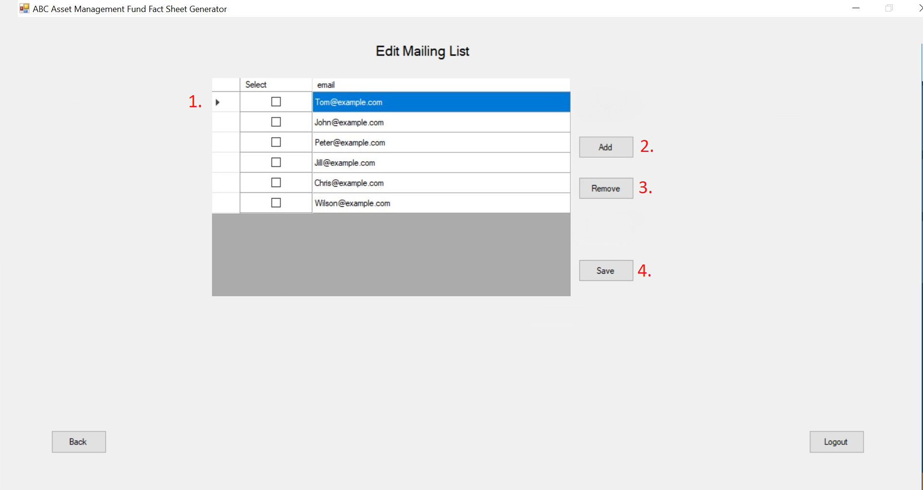

Parameters Passed
1. There will be checkboxes to indicate which email to remove.
2. The add button will allow the user to add an empty row
3. The remove button will allow the user to remove an email

Validations

4. The save button will allow the user to update and send the edited mail details to the database. An error message will appear if there is any duplicate email or if any email is invalid.

Process Specifications

Program structure chart
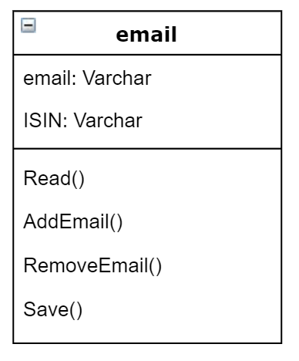

Pseudo code

Read{
Retrieve email data table from email
}
AddEmail {
Add email to email data table
}

RemoveEmail {
Remove email from email data table
}

Save{
Open SQL Connection
Drop old email data table
Add new email data table
Close SQL Connection
}

Output Specification

Files/Tables

email
Field Name | Data type | Size | Constraints | Remarks
email | Varchar | 50 | Primary Key
ISIN | Varchar | 50 | Foreign Key

Screen Layouts

Report Layouts

Parameters Passed
- email
- ISIN

Output formatting

Performance
Performance Requirements | Design | Constraints
Validation for email | No duplicate emails
Validation for email | Only valid emails are allowed

Security

Application Areas | Identify special transactions and areas requiring Encryption
Application Data | Identify data that requires Encryption
Encryption in Transit/Storage | Identify need for Encryption while data transfer or storage
Encryption Policy | State the policy that governs Encryption

Reuse or Third-party component

External component | Module impacted | Assumptions and Constraints | Source/License

Template Revision History (For EPEX Use Only)
Version Number | Release Date | Description of Change/s made | Author  (Name & Role) | Reviewer  (Name & Role) | Approver  (Name & Role) | QMS Release Version
1.0 | NA | Initial baseline | NA | NA | SEPG | NA
2.0 | Jun-14-11 | Assigned artifact id, version #, release date to the template and modified Information Classification label in the footer | Shreevidhya Srinivasan, PM | Radhika Seenivasakan, SEPG | Rajesh Sreekumar, SEPG | 4.2
2.1 | Nov-30-18 | Modified SEPG references to EPEX as a part of Re-Org | Prakash Palaniswamy, EPEX | Pradeep Kumar Pullathil, HEAD, EPEX | Pradeep Kumar Pullathil, HEAD, EPEX | 7.5

